Javonta Young

Assignment 5.2

Field- FIELD() function returns the index position of a value in a list of values.

You would use this to know where certain values line up in your list.

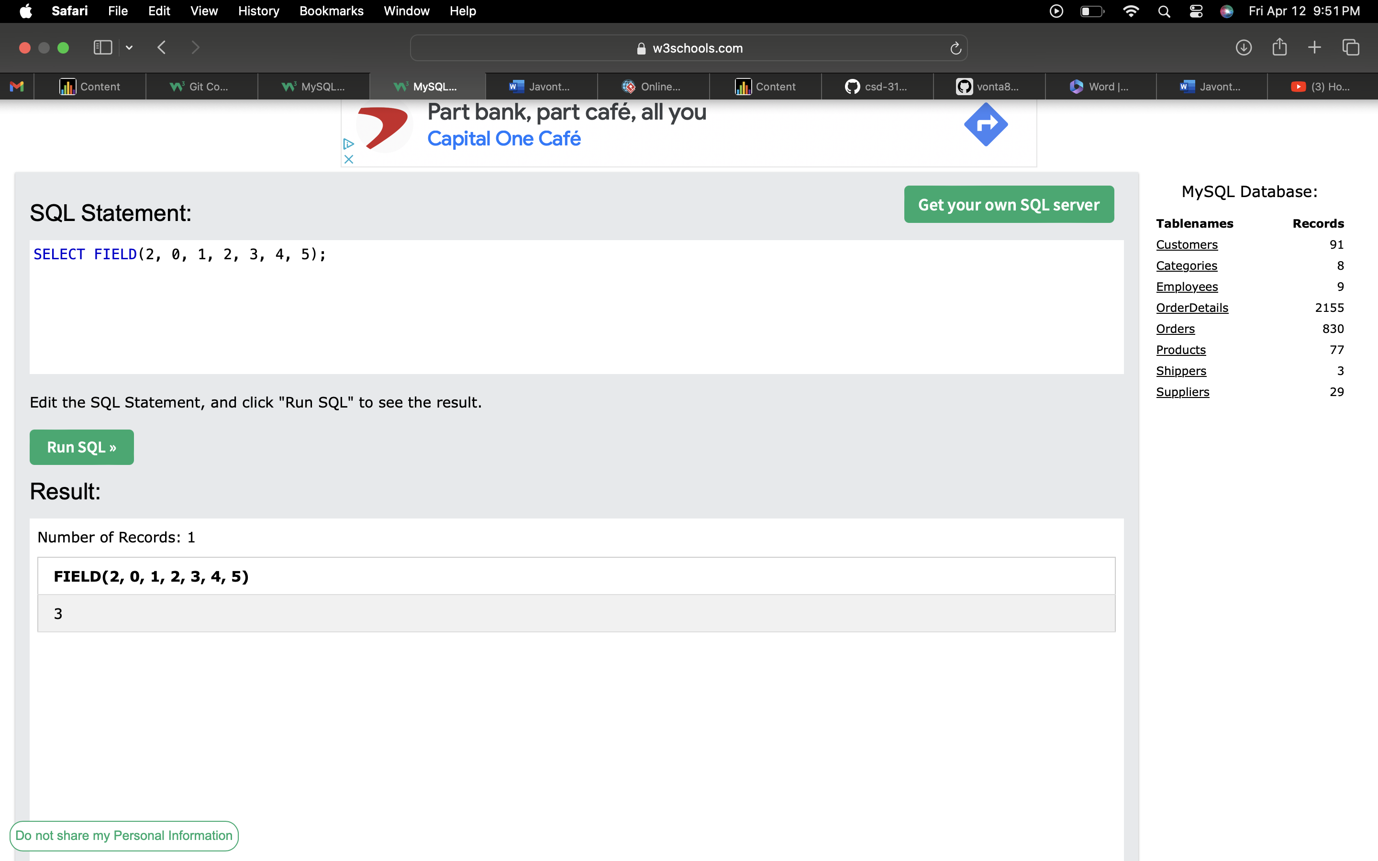

Left- LEFT() function extracts a number of characters from a string (starting from left).

You can also do it from the right using RIGHT()

This removes however many characters you want from the string. You would use this if you wanted to select only a certain amount of letter or display a certain name or letters.

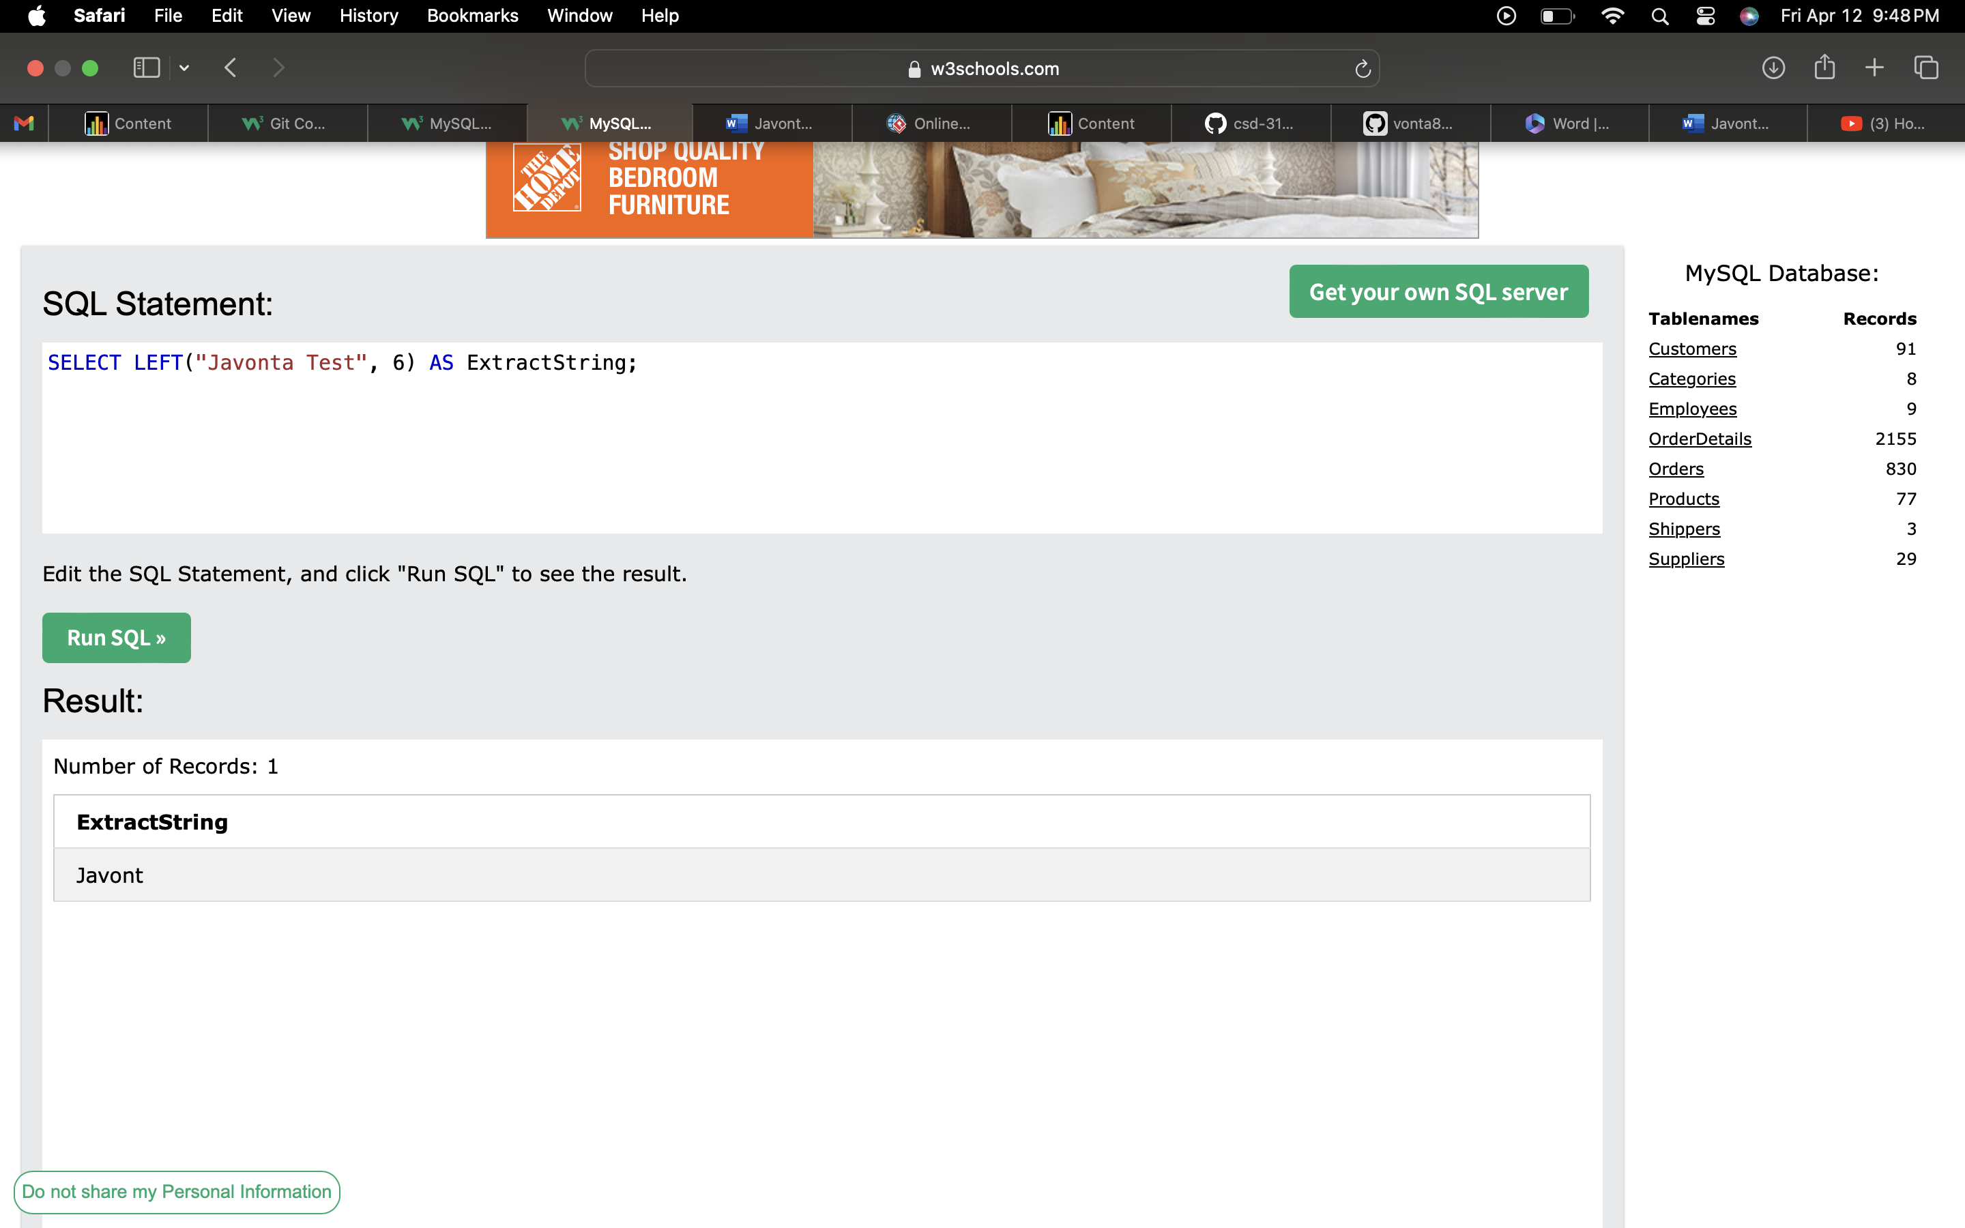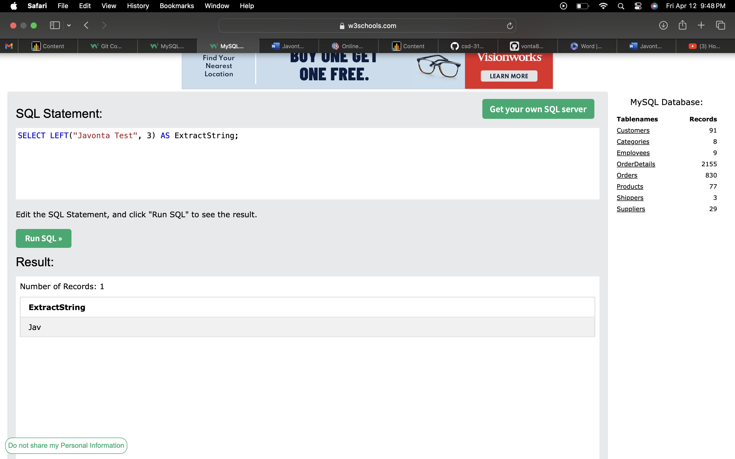

Trim- Removes leading or trailing spaces in a string.

Trim() is basically a remove spaces function.

You would use this when you have too many spaces within your code. It helps clean up your strings.

